1) | Name Of the Borrower and Branch
2) | Name of the owner of property
3) | Date of inspection of property
4) | Location of the property
State, District, Taluka and Village |  | Local name, If any of the plot | Survey No. |  | Extent
5) Classification of property (urban/semi urban/rural)
6) The details of the route through which property can be reached
7) Has the property got direct & independent access
8) Is the property accessible by car/mode of accessibility available
9) Boundaries
Boundaries |  |  |  | Present |  | As per Document
East
South
West
North
10) Is the Property Clearly Demarcated
Ref: UCVLLP/NKGSB/6467 Date: 27/12/2024

11) Certificate for having verified the documents of title the relevant office of revenue authorities to identified the property and to confirm ownership

11a) Date and Registration Number & title Deed & Name of Registration Office

11b)Value / Purchase price paid as per document
12) Nature of land (Agricultural Plot , House Plot , Commercial Plot, Irrigated , Non Irrigated, etc)
13) General Description of layout (Flat land , Sloppy land, etc)
14) In case of agricultural land , name of crops with area & age of plants
15) Other development on the property excluding building
16) Nature of boundary (fence/stonewall/mud boundary, etc)
17) Possession of the property (owner‘s/third party)
18) If it is in third party’s possession , nature of tenancy
19) What is the value of average annual gross yield at the present market rate.
20) What is the net annual agricultural income from the property
21) Locational advantage (nearness to public utility establishment like Educational Institutions, Hospitals, Post office, Market, Railway station, Airport etc.)
22) Market trends and prospects of
marketability.
23)a) What is the present rate and market value of the property (excluding building).

b) Give details of source of information given under 23(A).

c) If any recent transaction in the neighborhood has taken place, give date, registration No., extent of property and consideration of the transaction. Also state how the said property compares with the present property under valuation.

d) Guideline value / notified rate, if any fixed by Govt. for stamp duty / registration.

VALUATION OF BUILDING
24) Building / building situated in the property with S. No. in which building is situated.
25) Municipal / Panchayat No. of building.
26) Nature of construction (Brick / granite walls, concrete / tiled / thatched roofing, single/ Multi storied construction etc.)
27) Nature of flooring
28) Age of building and whether well maintained.
29) Whether the building is constructed in strictly according to plan approved by govt. authority.

a. If not the extent of deviation.

b. Any action required to regularize construction / deviation.
30) Total plinth area ( floor wise)
31) Who occupies the building (Owner/ Third party)
32) If occupied by third party, describe nature of arrangement (lease etc.)
33) Estimated rental value of building.
34) Replacement value of building.
35) Depreciation calculated and depreciation value of building.
36) What is the value of building that may fetch on forced sale.
37) What is the value of building that may fetch on a realizable sale.
38) Taking into consideration the above facts, valuation of Land & building fixed by valuer by cost approach comes to

Marketability:

Rate Analysis:

TECHNICAL DETAILS
1 | No. of floors, Type of Structure and height of each floor
2 | Plinth Area of the Premises
3 | Year of Construction
4 | Estimated future life
19 | Latitude & Longitude
20 | Accommodation
21 | Amenities

Disclaimer, Notes and Limitation:
- We have finalized the report on the basis of site visit and copy of: Digitally Sign Approved Plan, Lease deed, GIDC Approved Plan Letter, Possession Letter & old valuation report only. However, we have not been provided with B.C.C., O.C., for verification purpose.
- The said property area considered as per 30% work of Completion.
- Property is situated in Industrial area.
- The said property has Boundary Wall with barbed wire fencing.
- Property is inspected as shown by person met on site Mr. Vivek Shahoo- Manager.
- Well Demarcated & Main road touch.
- The said property is in running condition used as a Godown.
- As per the provided documents the land on which the building is situated is on leasehold basis for 99 years.
- Currently Ground Floor work is completed & remaining work is under progress, At present only 30% work is completed.
- The said property is ground + 1st upper floor at present constructed only ground floor due to some problems the work has stopped since 1 year and have no idea about to start the work.
- We consider the area given in the Lease Deed & Digitally Sign Approved Plan declared by the party and submitted for registration with the government authorities as final for valuation. Any area that is not stated in the Lease Deed & Digitally Sign Approved Plan is not considered for valuation unless the area is measured by us in which case that may be considered for valuation purpose.
- The scope of our valuation work is only for banks financial/loan purpose. Further, please be noted that this report shall not be used for any litigation purpose.
- Encumbrance of Loan, Government and other dues, stamp duty, registration charges, transfer charges etc, if any are not considered in the valuation. We assumed that the assets are free from encumbrance unless otherwise stated to us by the party in writing.
- The value given in our report is the estimate of the Fair Market value of the property as on date, considering various aspects of the property as mentioned above.
- The value given in the report is the estimate of the Fair Market value of the property as on date, considering various aspects of the property like amenities in projects, locational advantages, demand and supply equation, interior designing done in the property, outside view, Vashtu aspects etc. which is generally more than the Government ready reckoner value.
I hereby declare that:
- The property was inspected by our Engineer, Mr. Prasad Marathe on 26/12/2024.
- I have no direct or indirect interest in the property valued.
- The information furnished in the report is true and correct to the best of my knowledge and belief.
- The names of Customer / Builder are taken as per technical and papers received with the technical and don’t take any liability regarding the same, nor title clearance of the Property.
- Validity of the value worked out regarding the concerned property is as on Date of the Report.
- Genuineness of original documents to be verified by bank Authorities.
Date: 27/12/2024
Place: Thane

Manoj Kumar Sharma
B.E (Civil), F.I.V., M.I.E
Govt. Regd. Valuer
Panel Valuer of NKGSB Bank
(IBBI/RV/07/2019/11044)

Photograghs:

Factory open plot
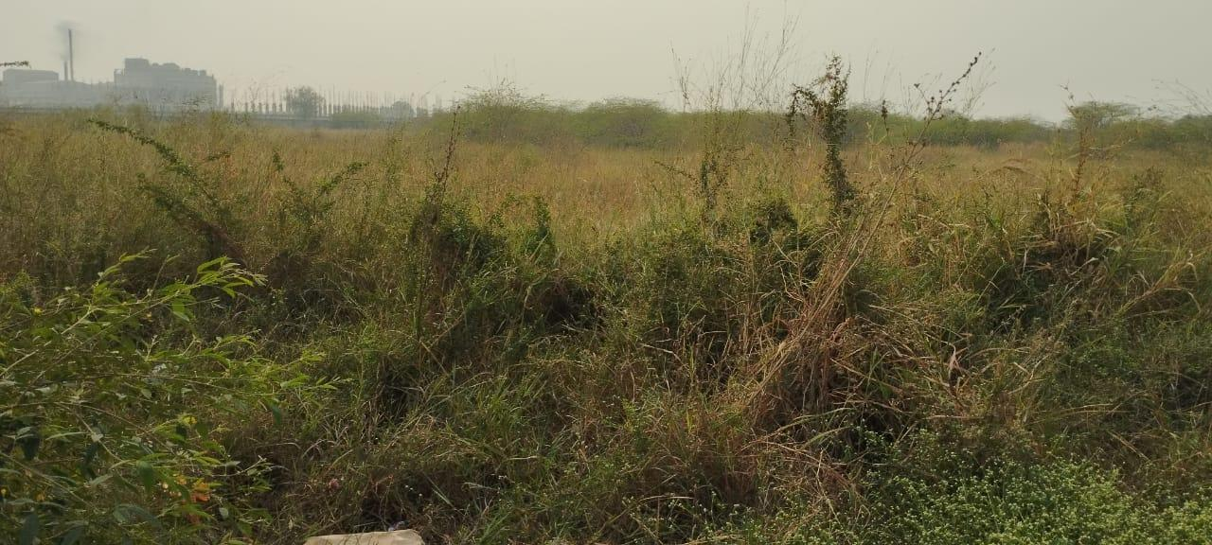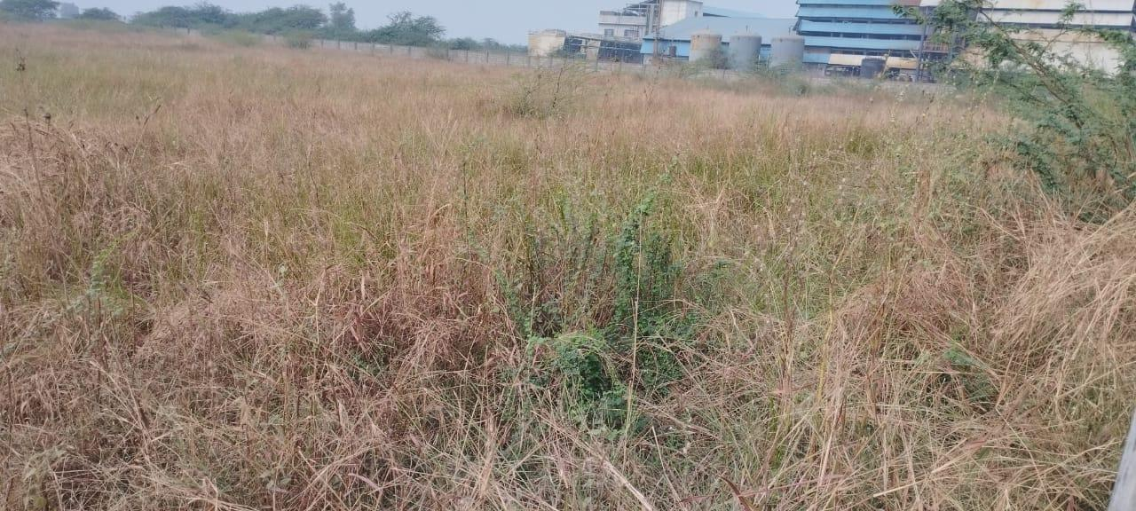

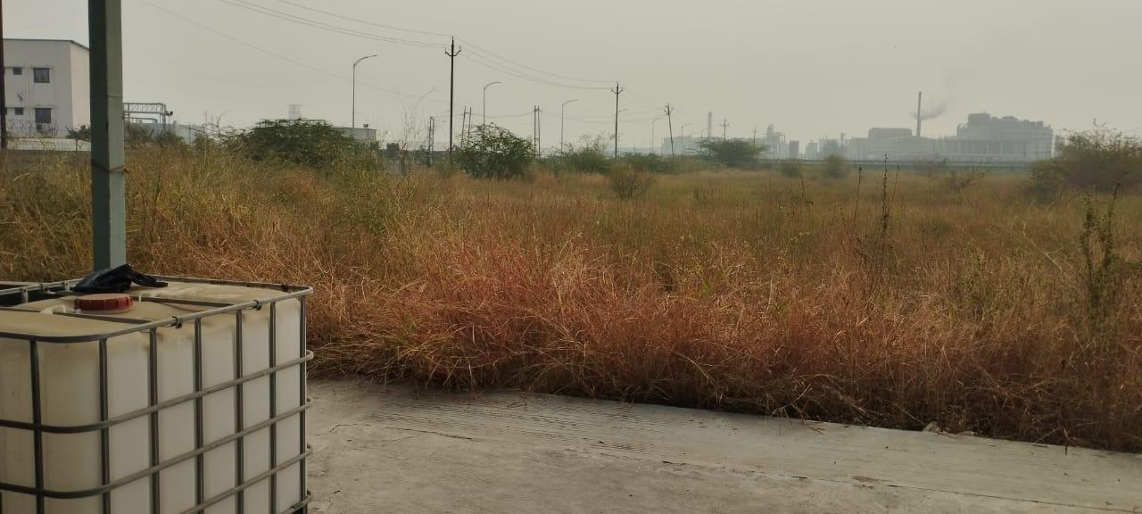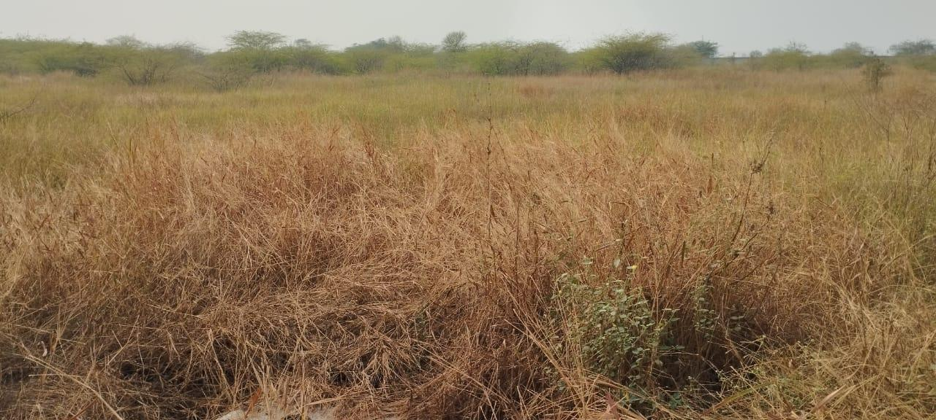

Generator platform
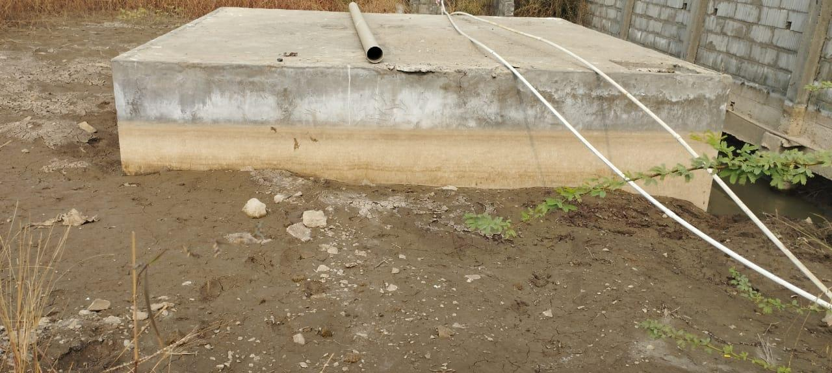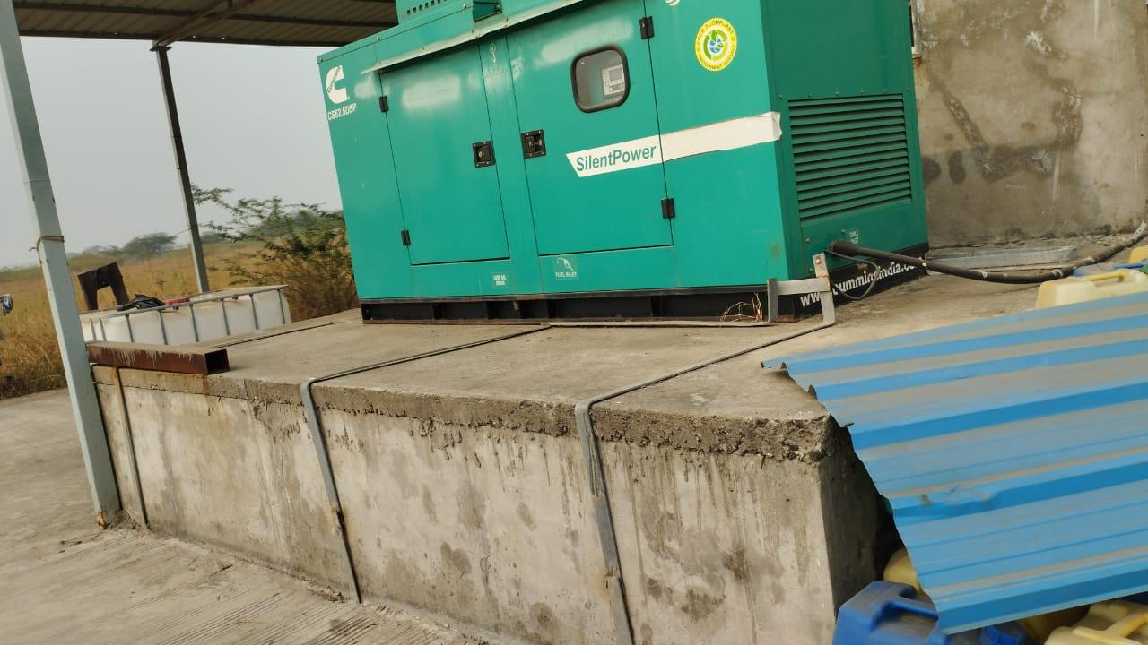

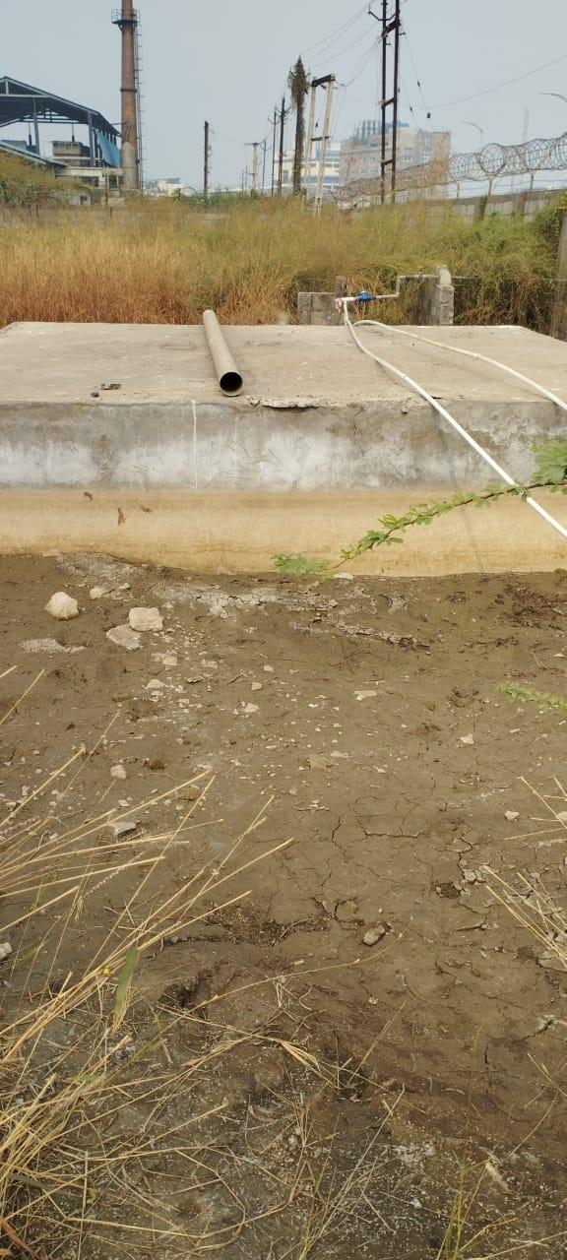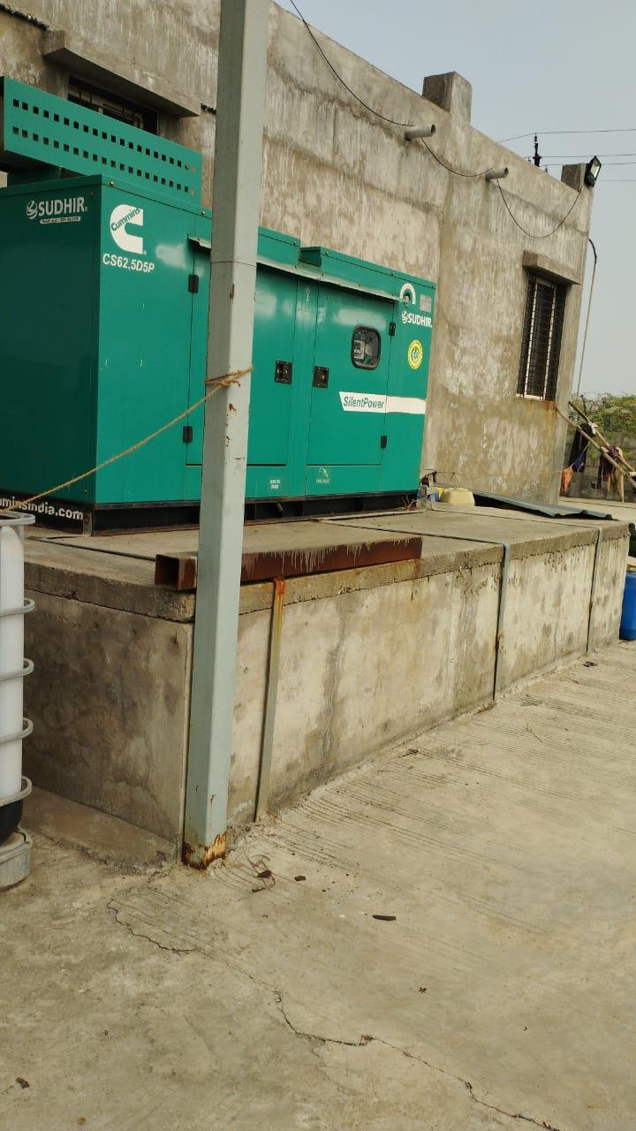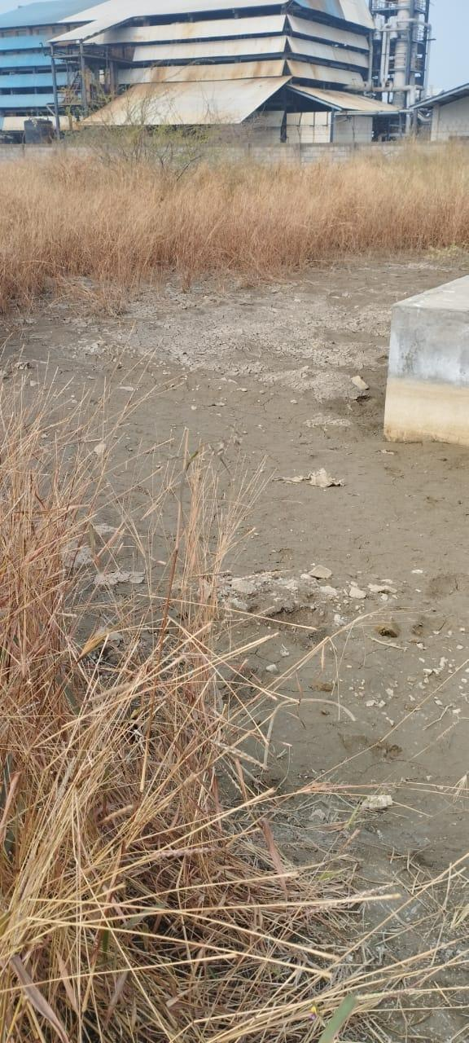

Shed Area
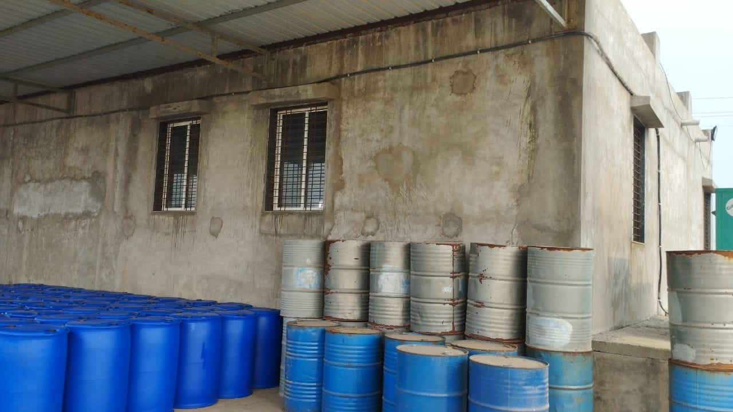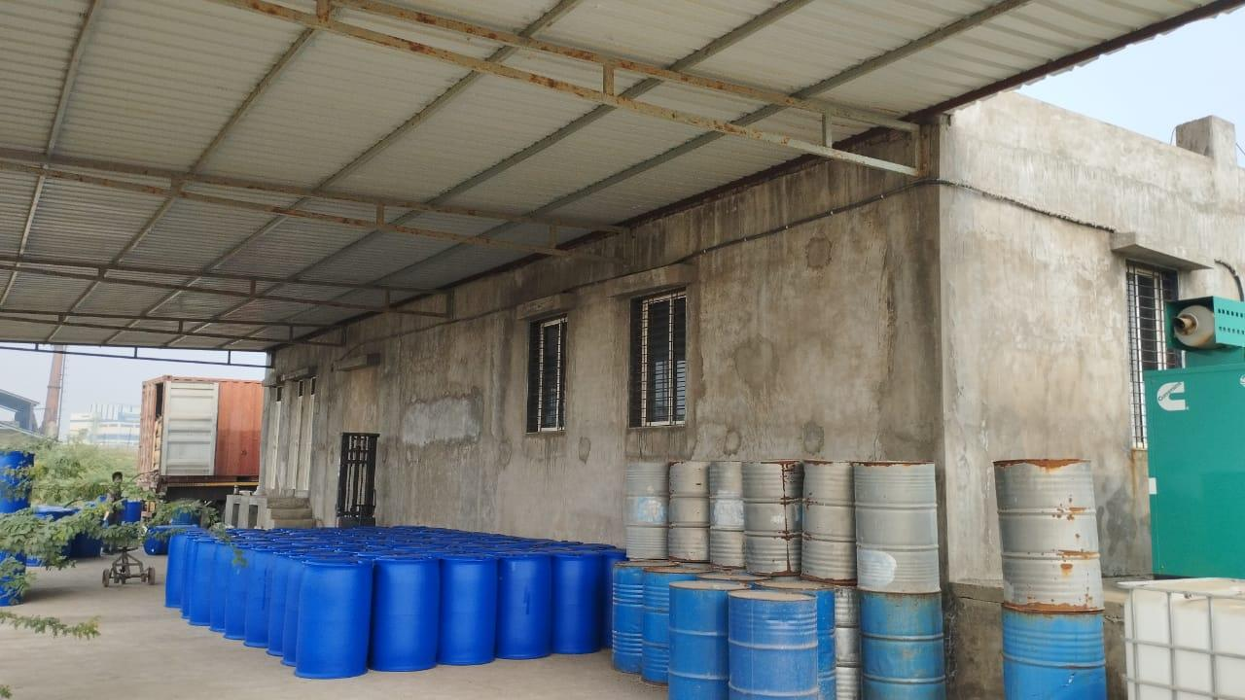

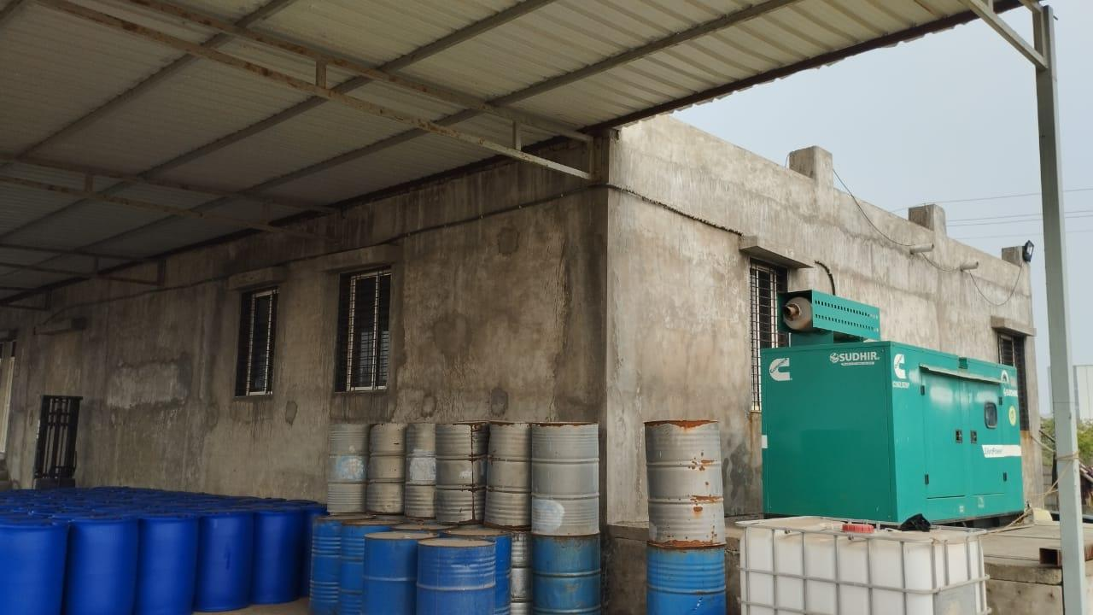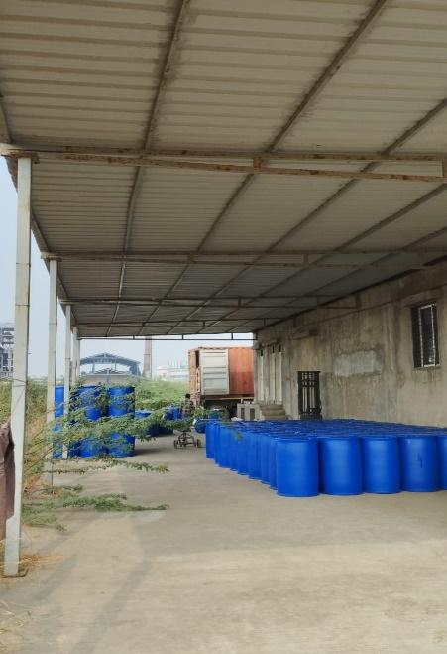

Factory structure External
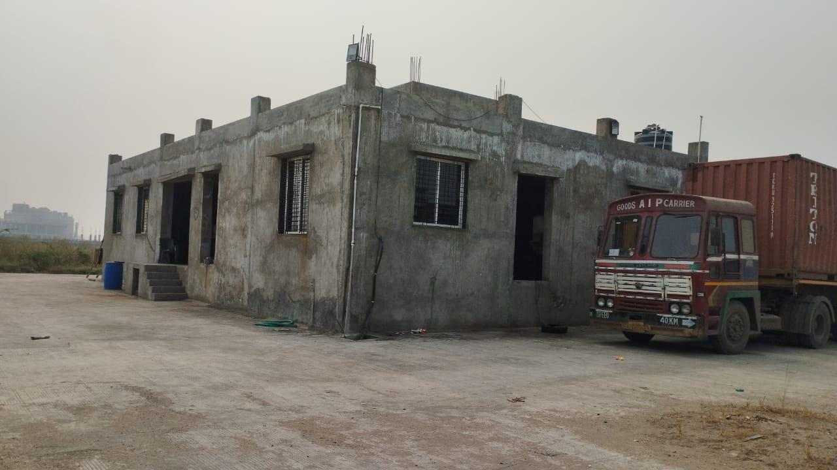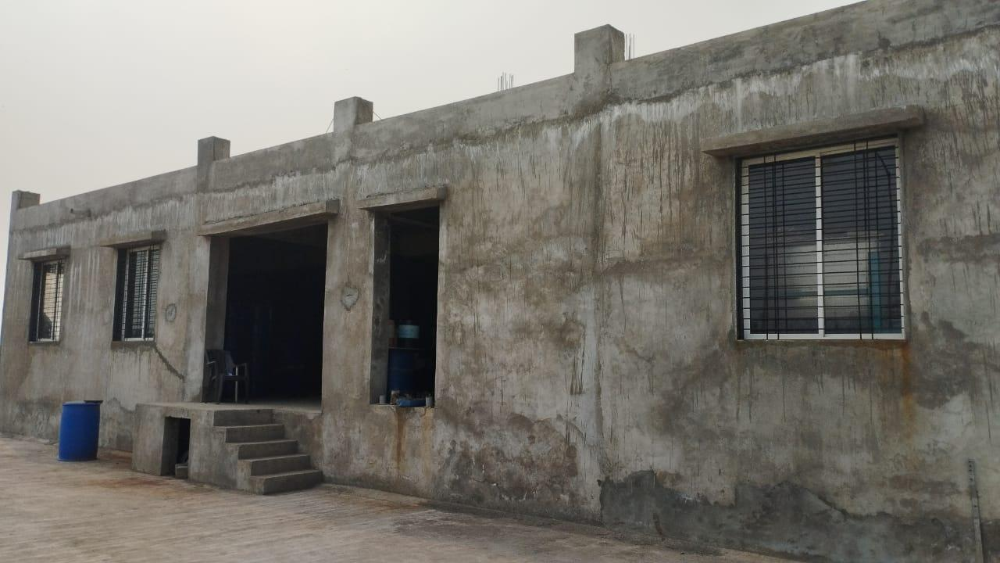

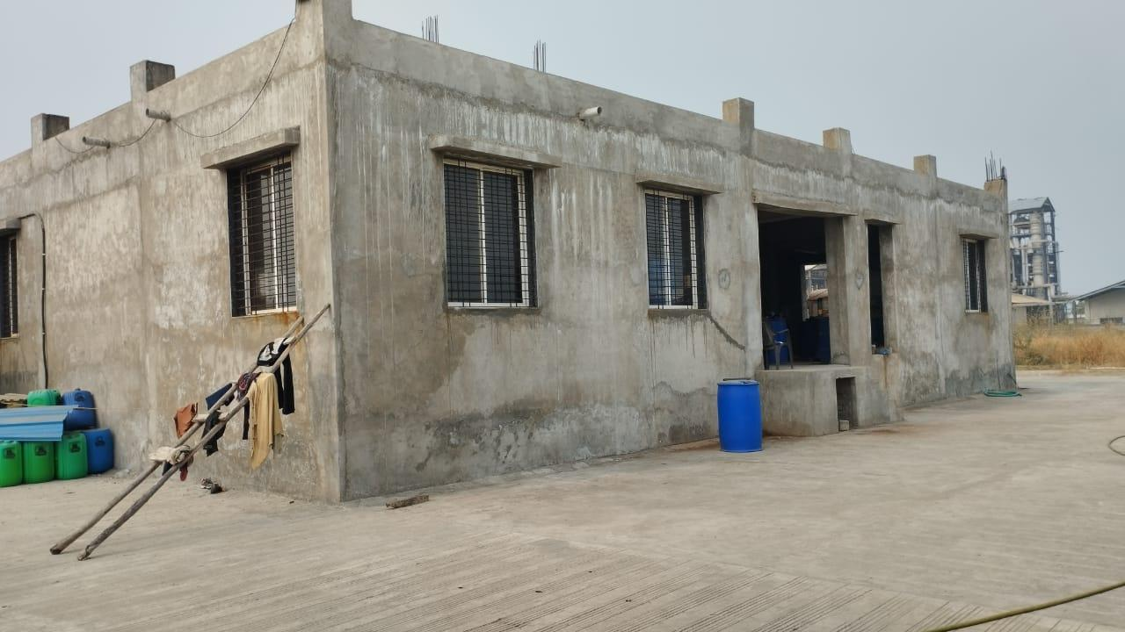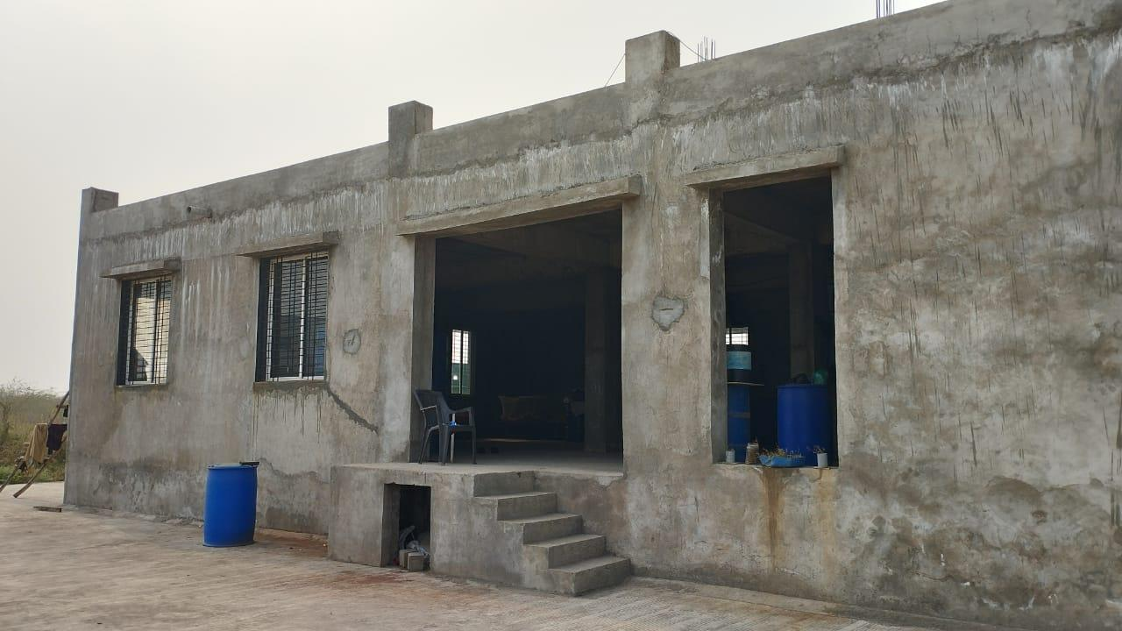

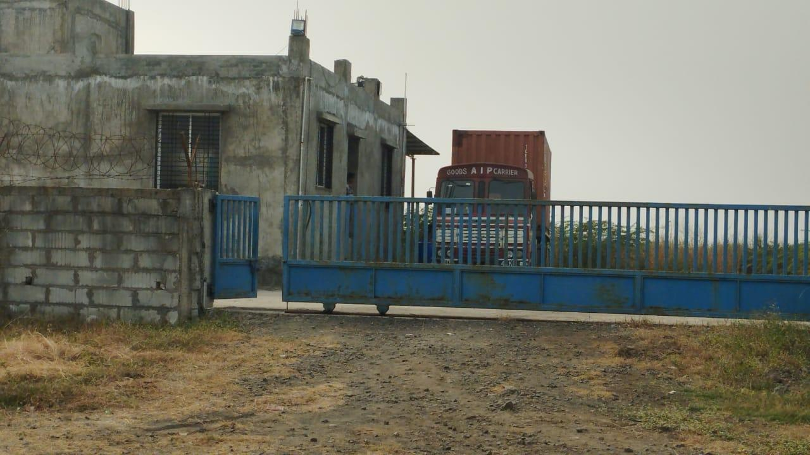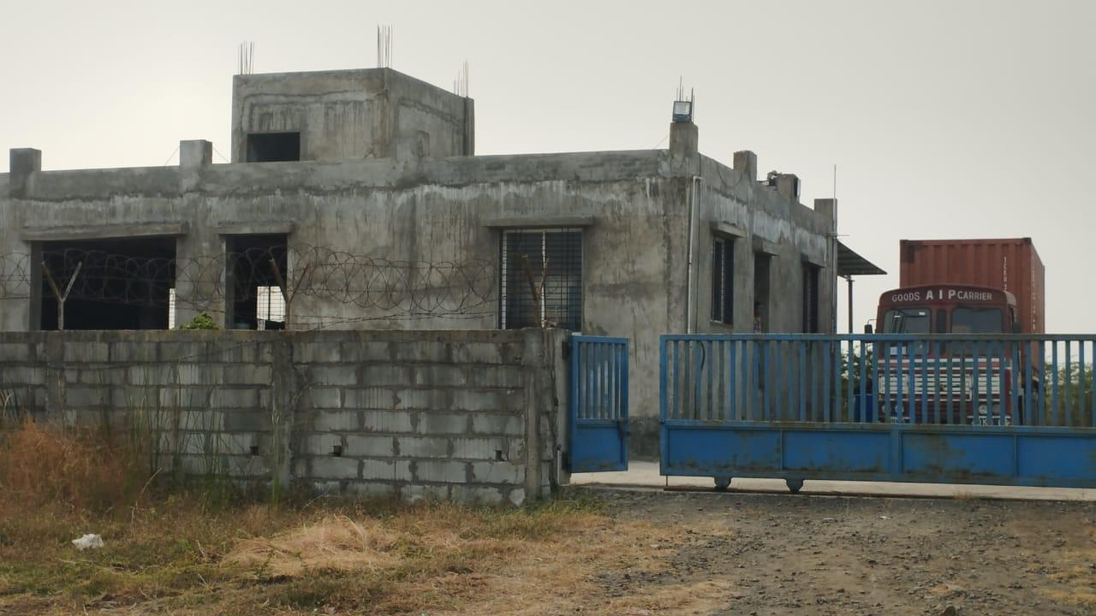

Factory structure Internal
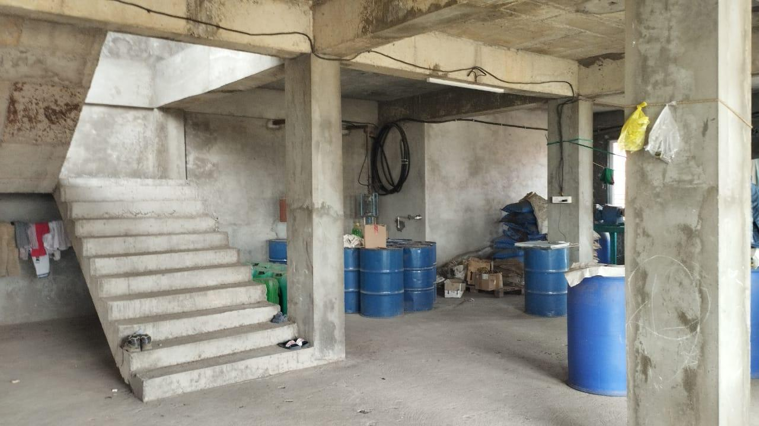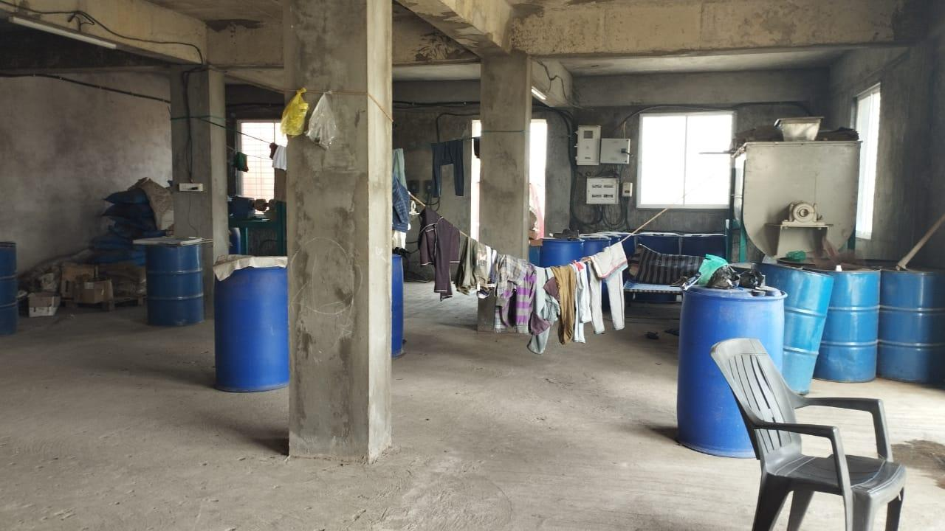

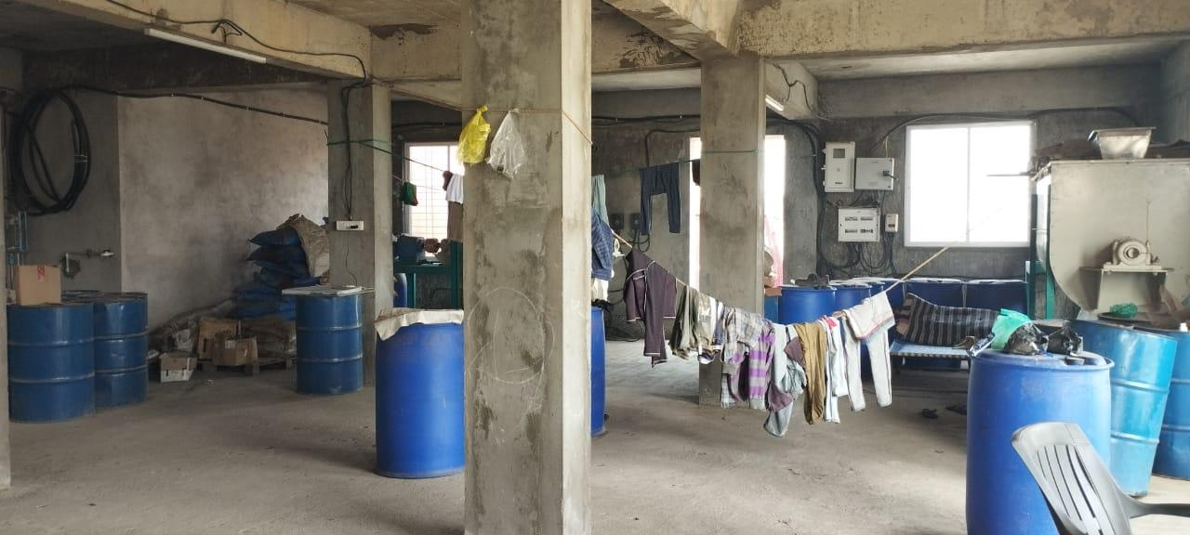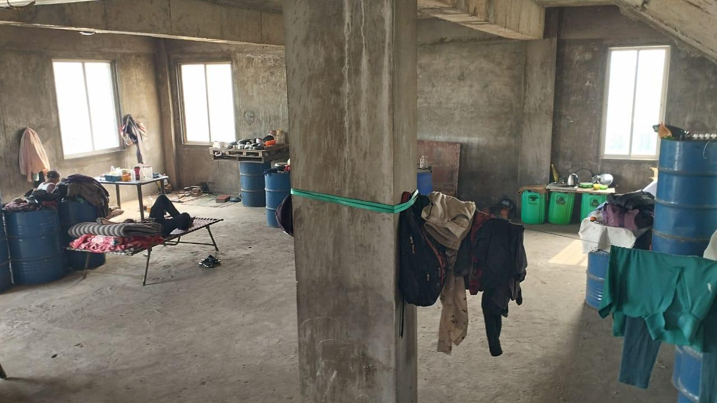

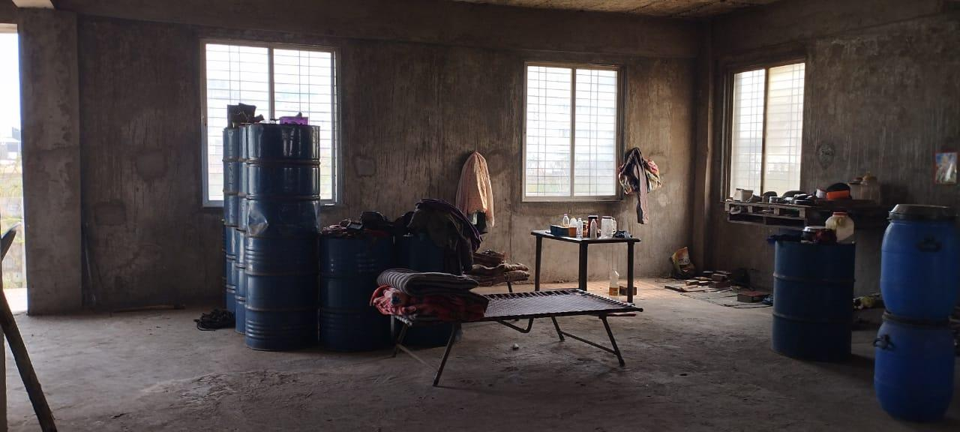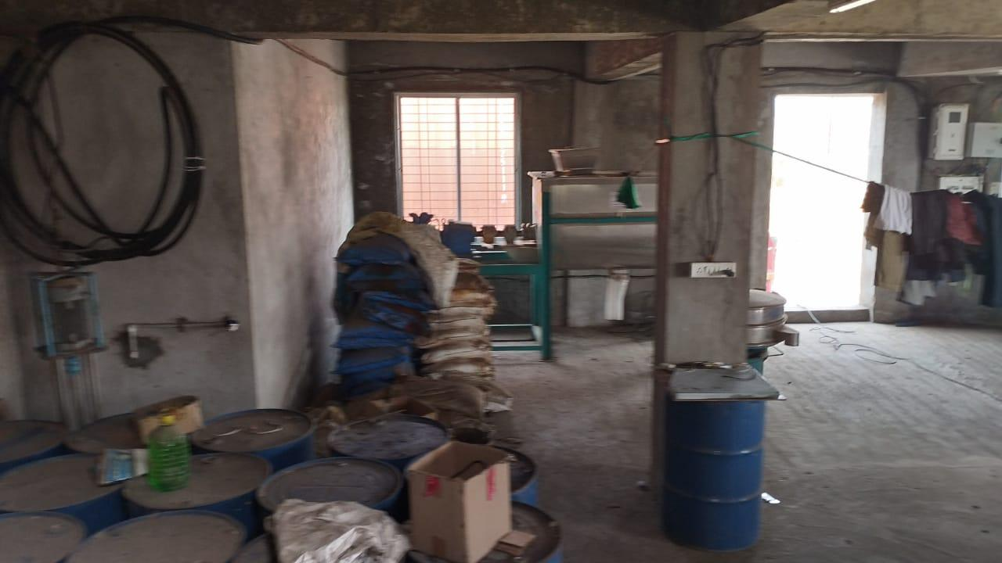

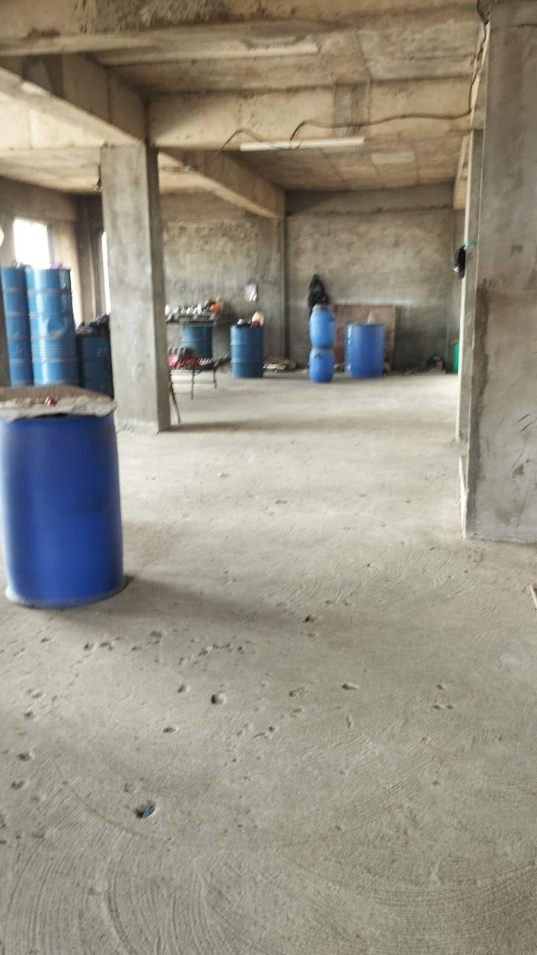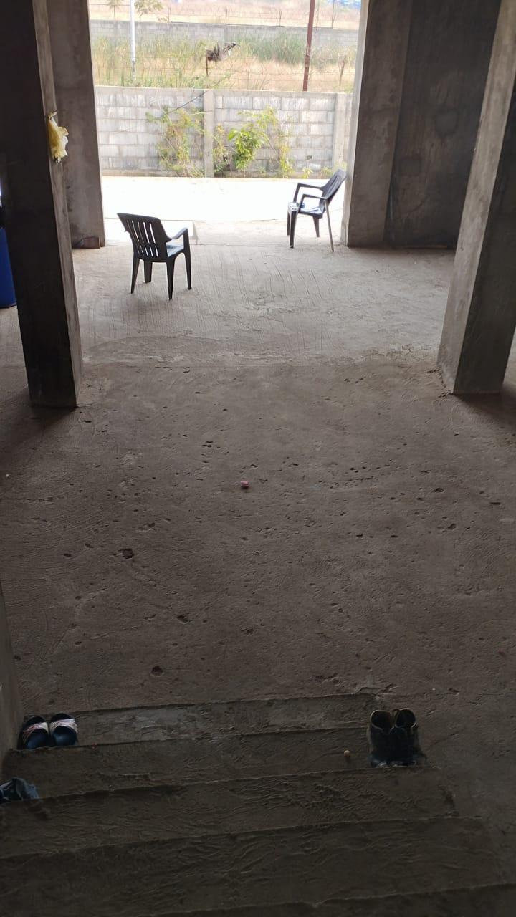

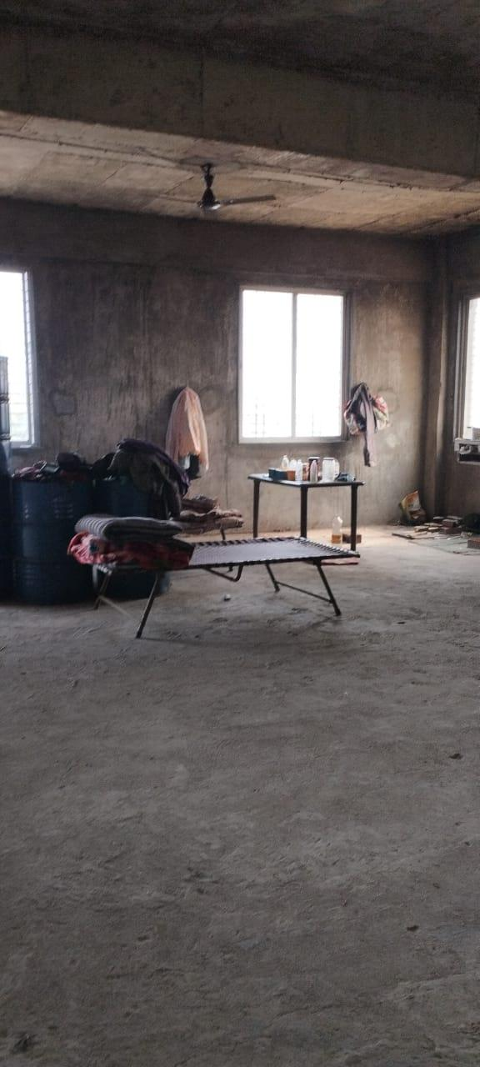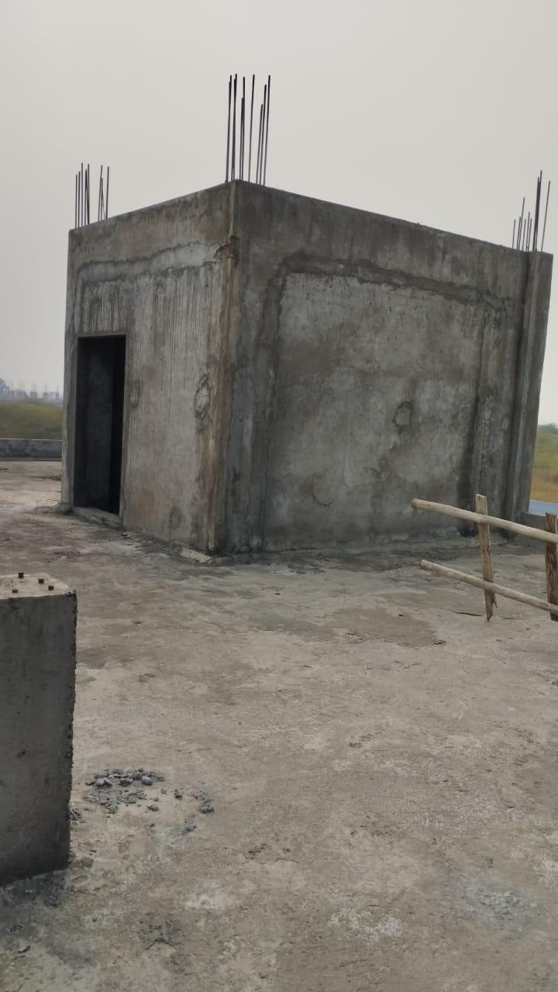

water tank
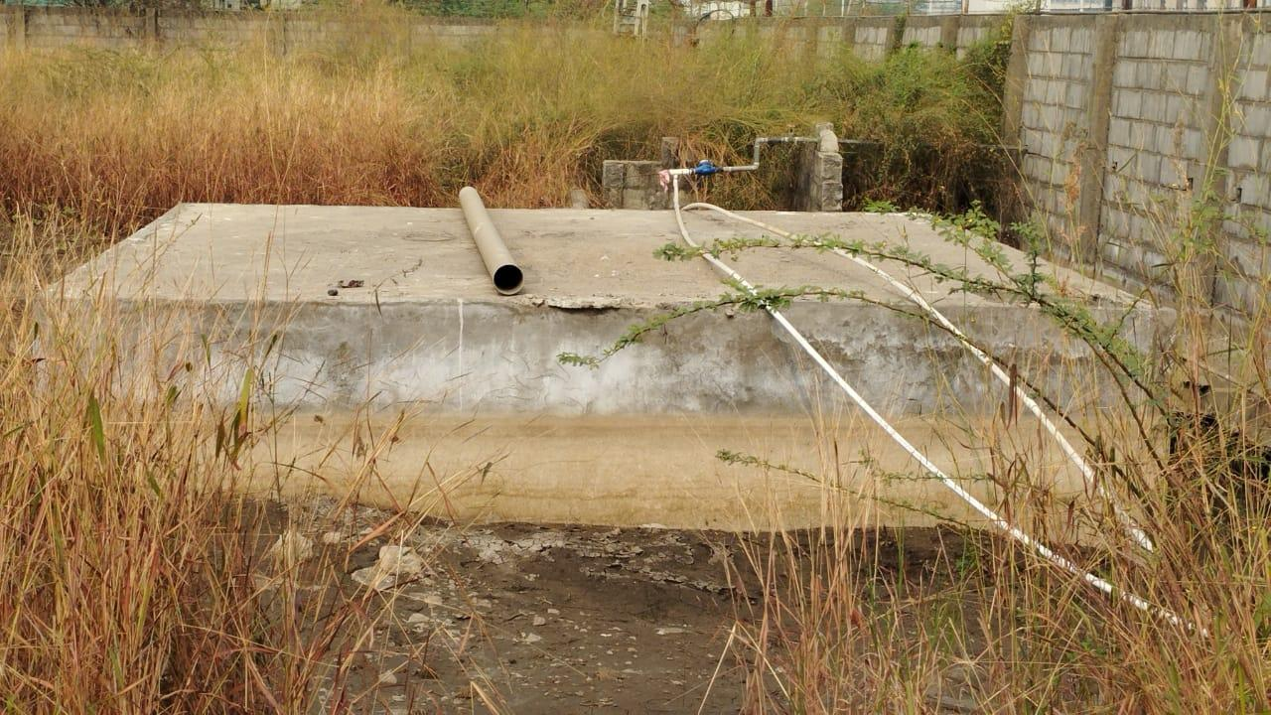
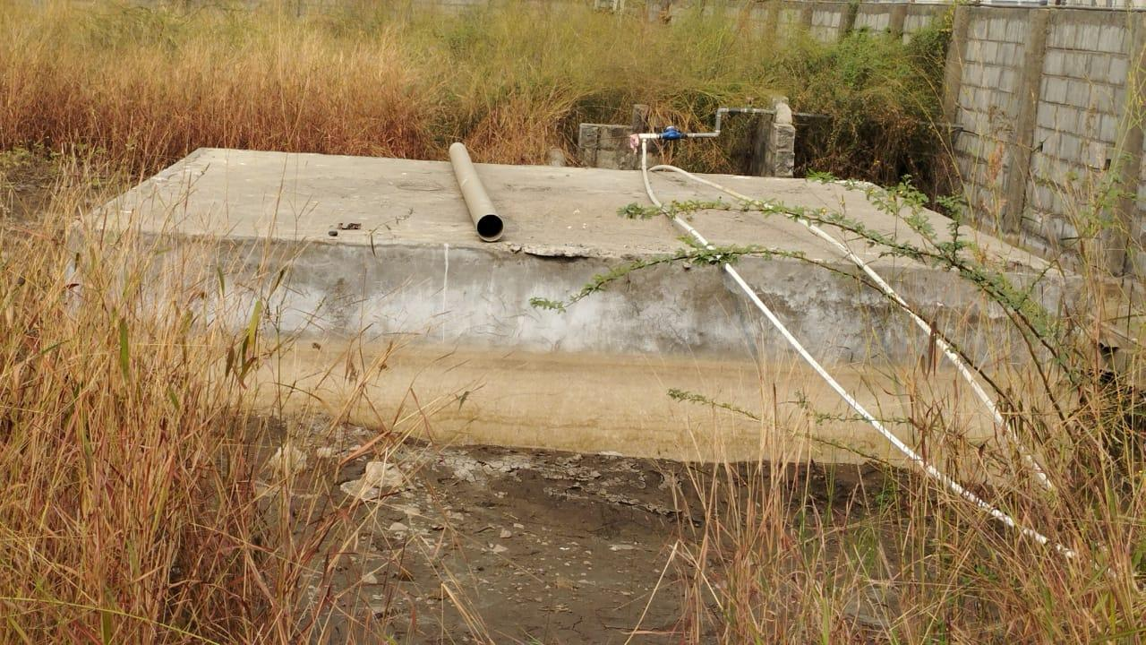
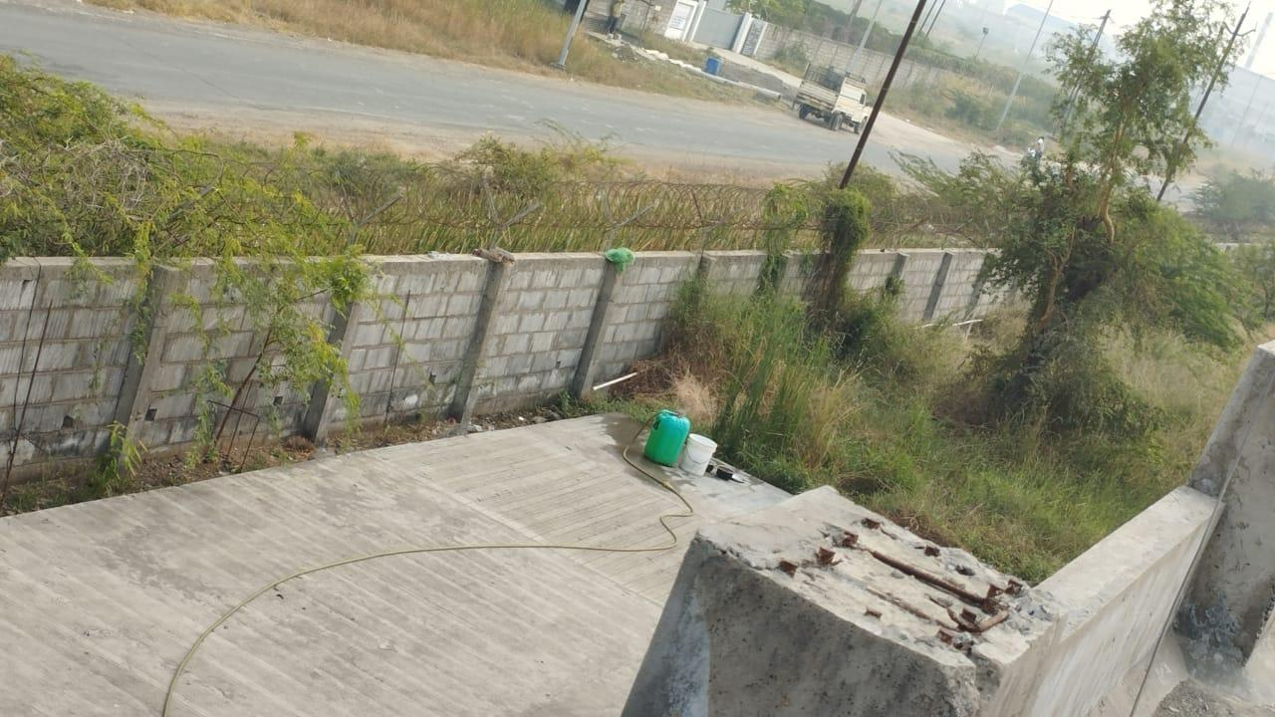
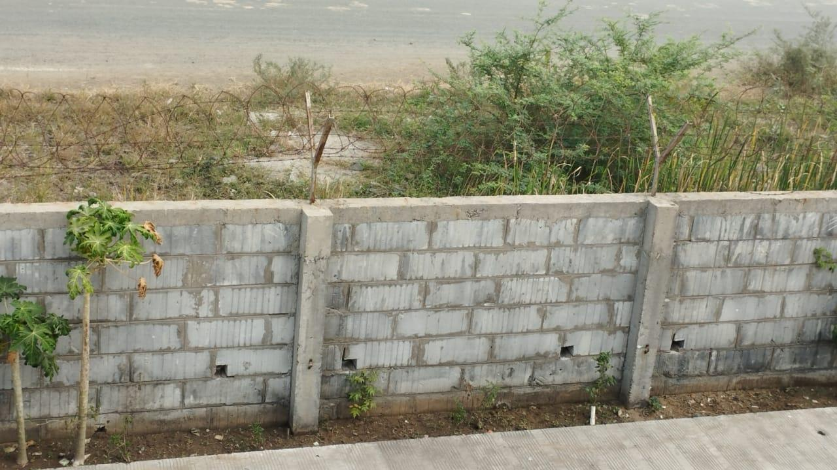

Google Map:
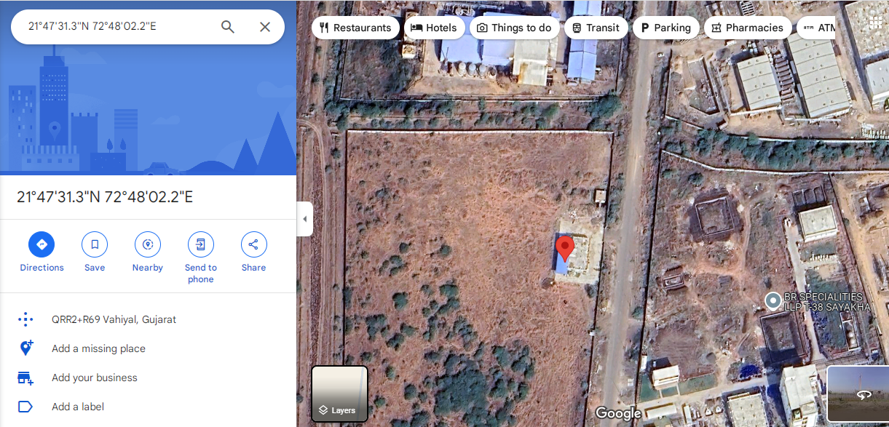

Gov. Ready Recknor Rate 2024-25:
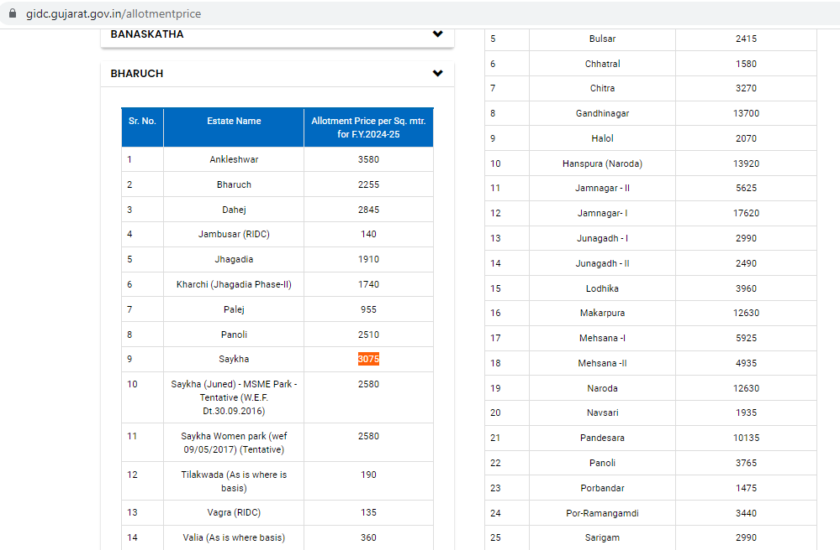

Comparables:

